**DECISION TREE VISUALIZATION FOR GERMAN CREDIT DATASET**

Step 1: Open weka Explorer

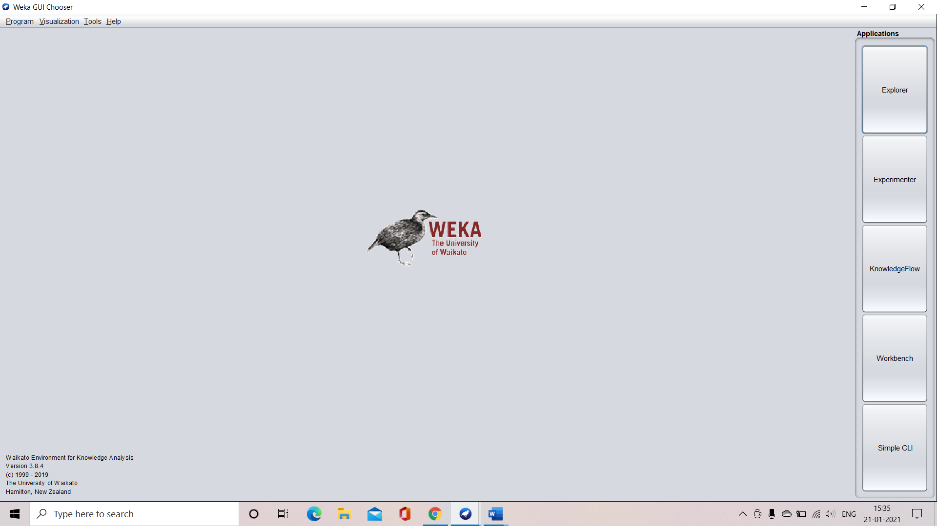

Step 2: Load the data set into weka

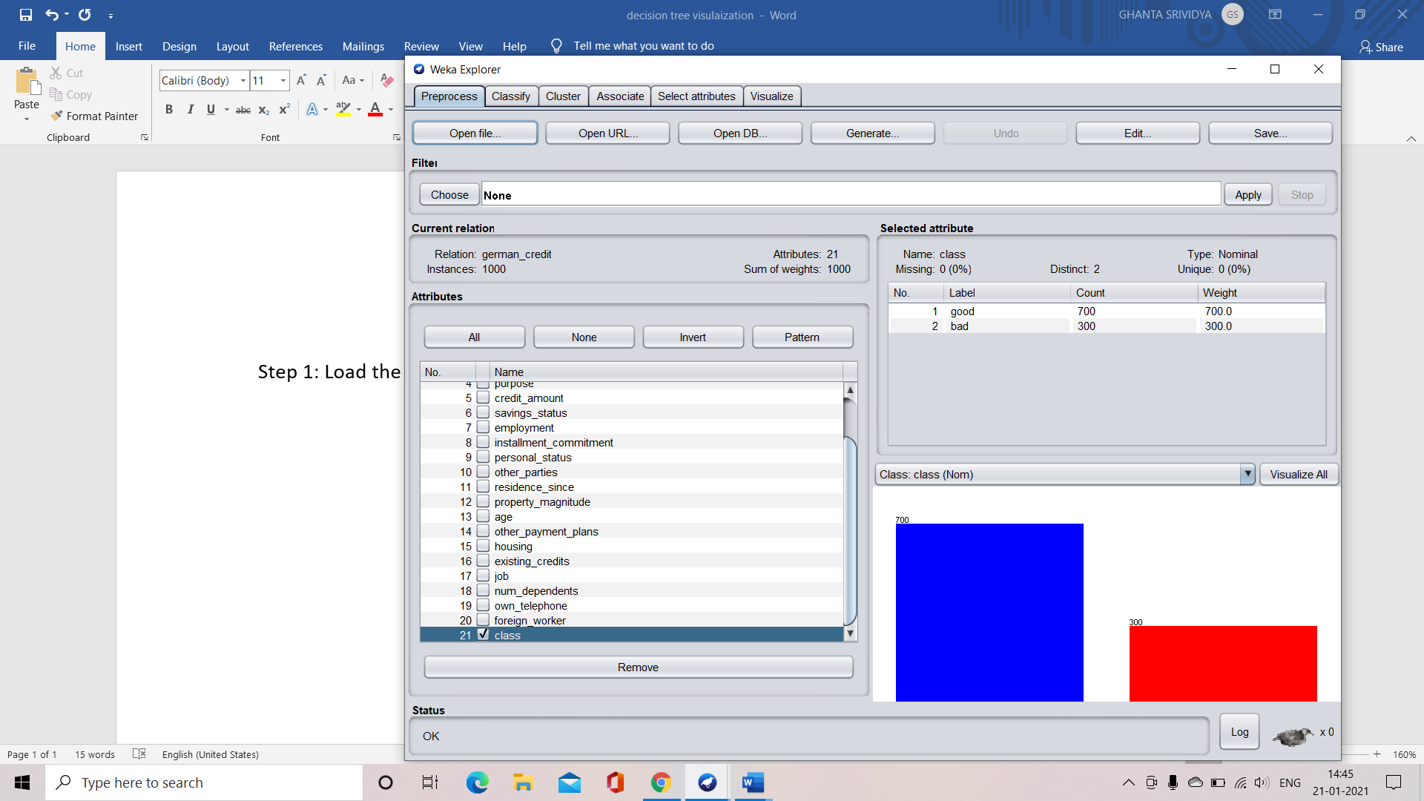

Step 1: Select the class attribute of the dataset

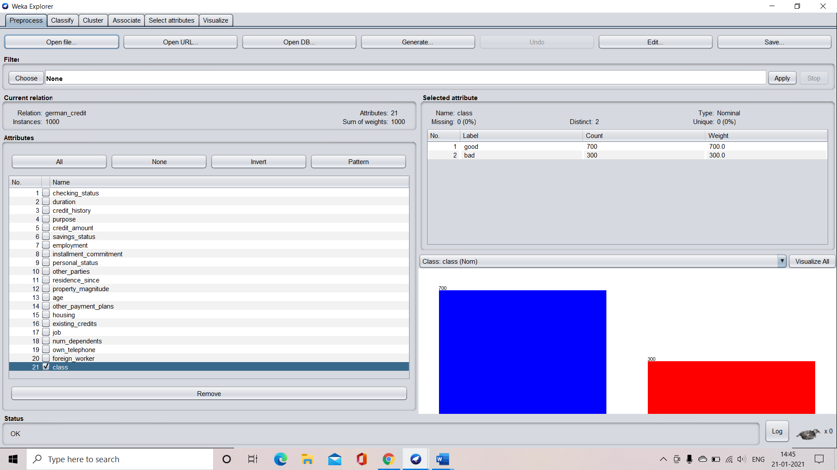

Step 4: Go to classify tab in weka and select “Use training set” option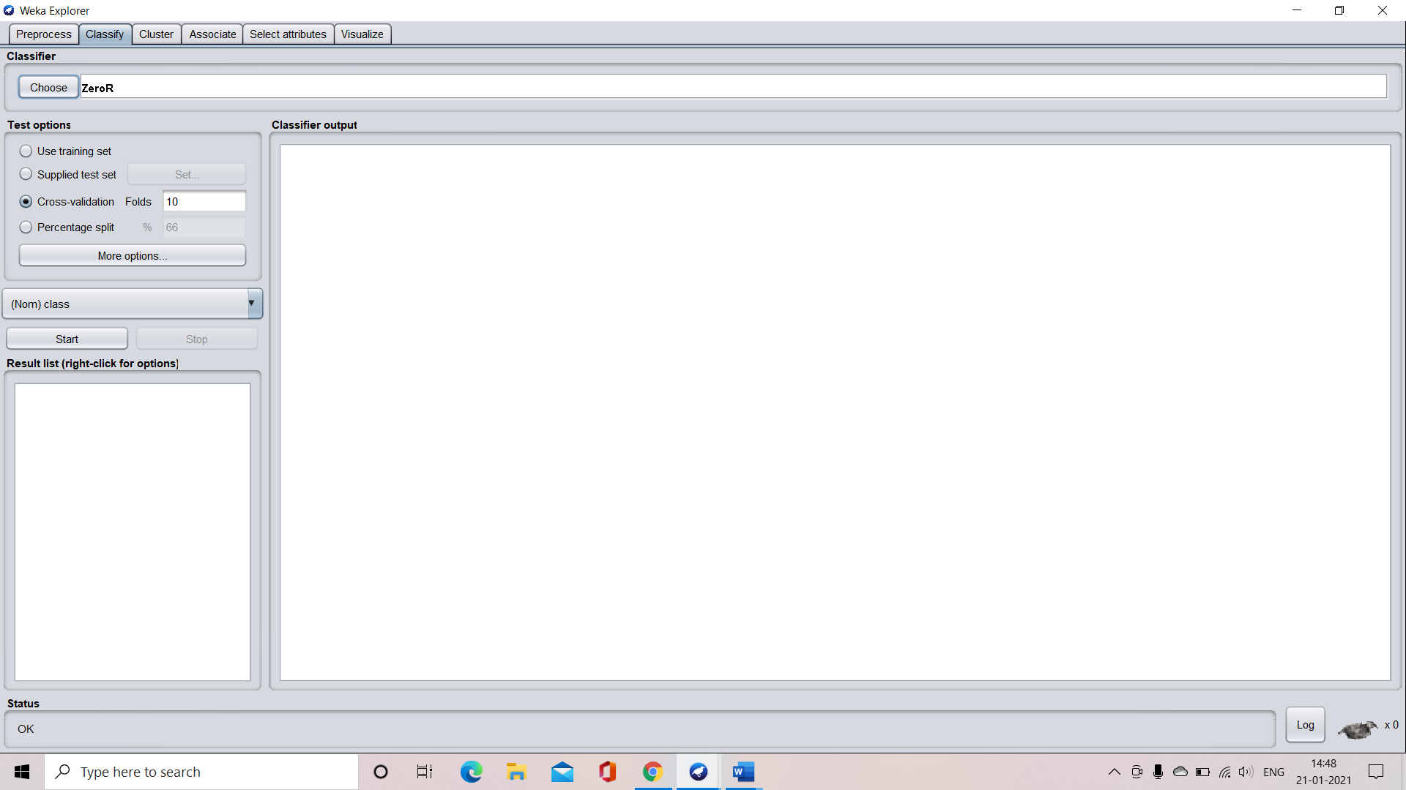

Step 5: Select the “Choose” button and in the “Tree” tab select “J-48” indorder to generate a decision tree and click “Start” button.

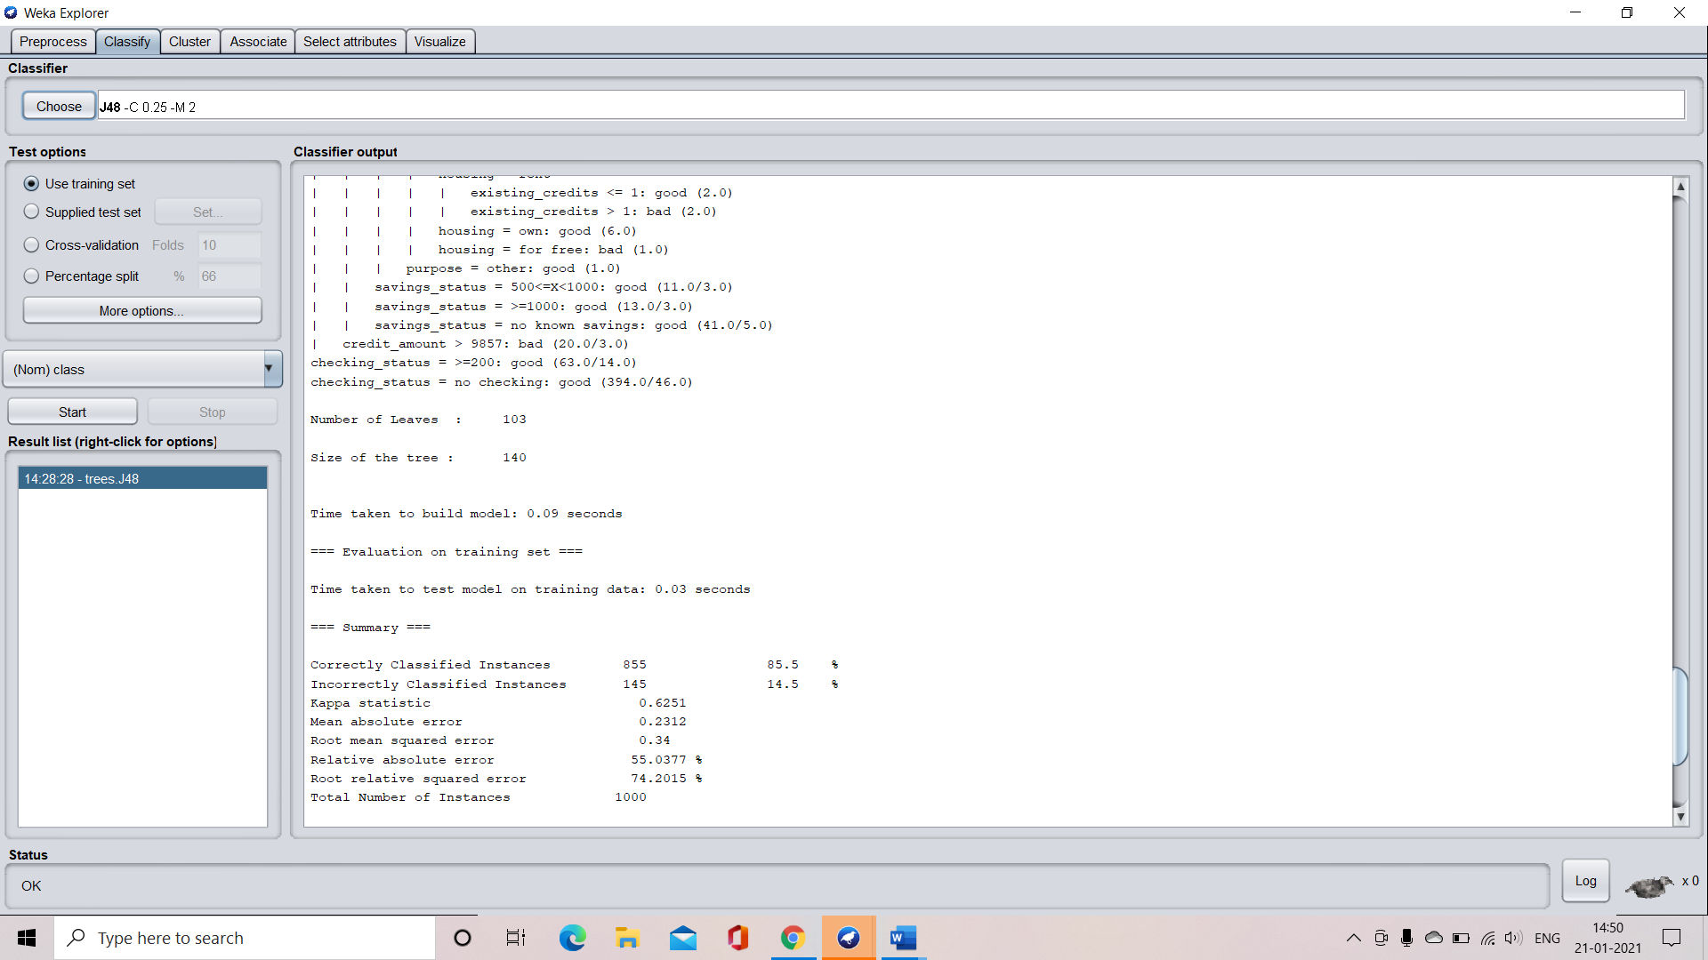

Step 6: Check the characteristics of the tree developed:

**CASE 1: for application of J-48**

Number of leaves 🡪 103

Size of the tree 🡪 140

Time taken to build the tree 🡪 0.09 seconds

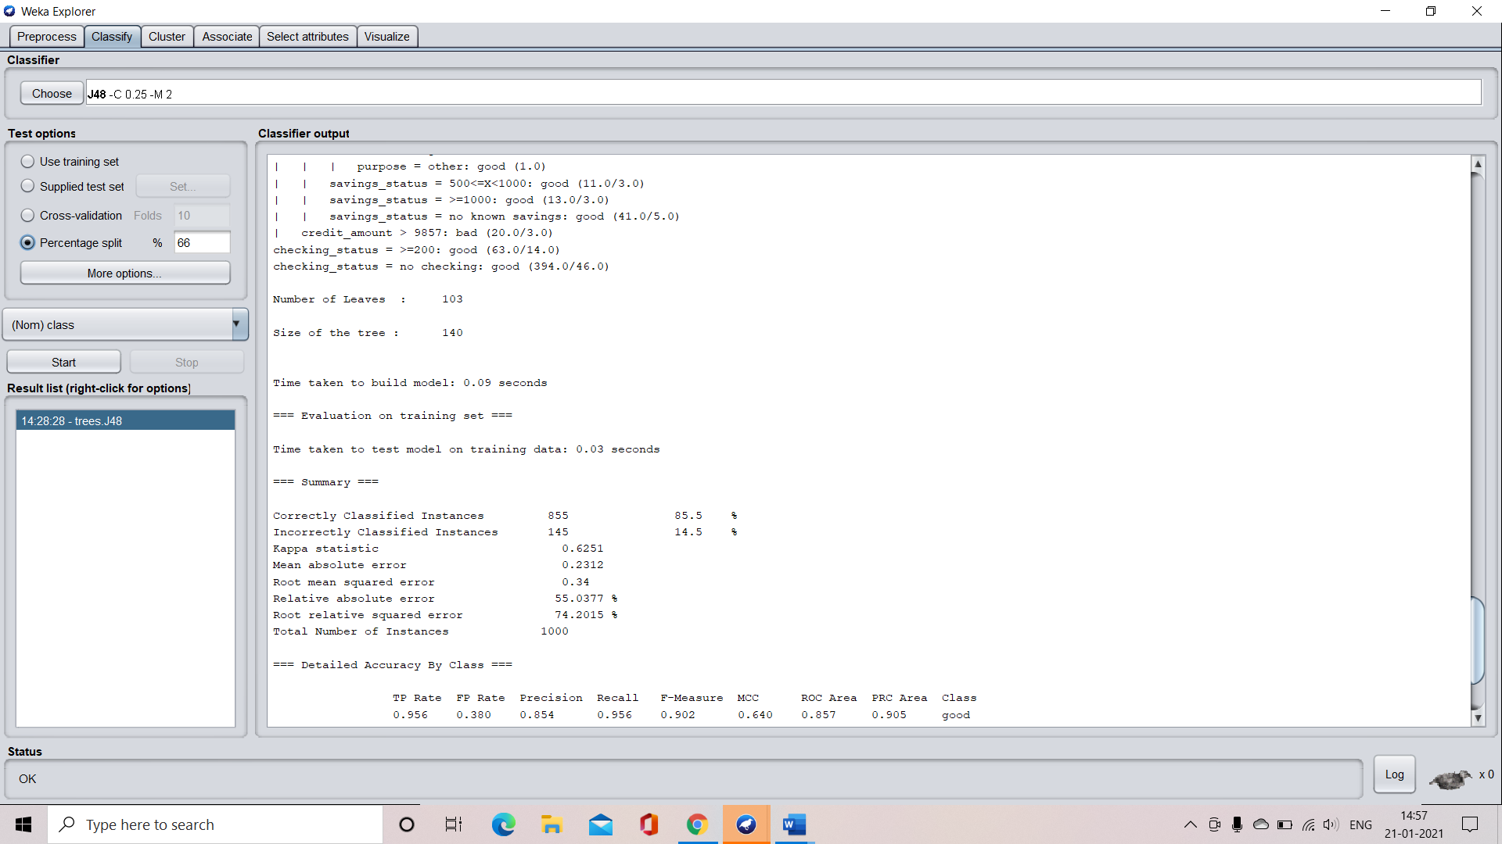

Confusion matrix:

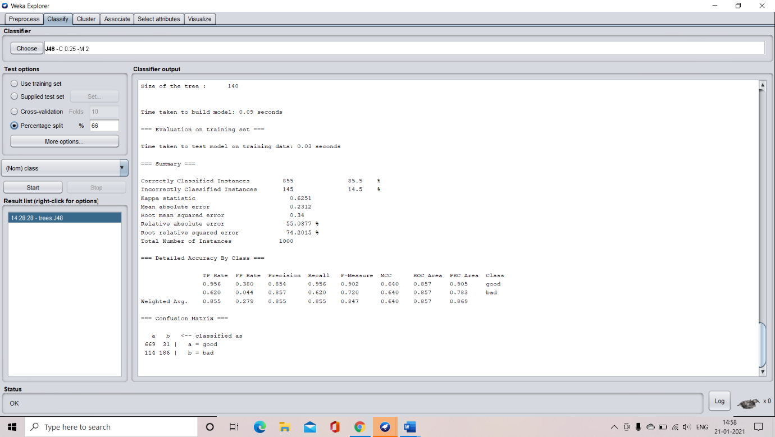

Accuracy of the decision tree:

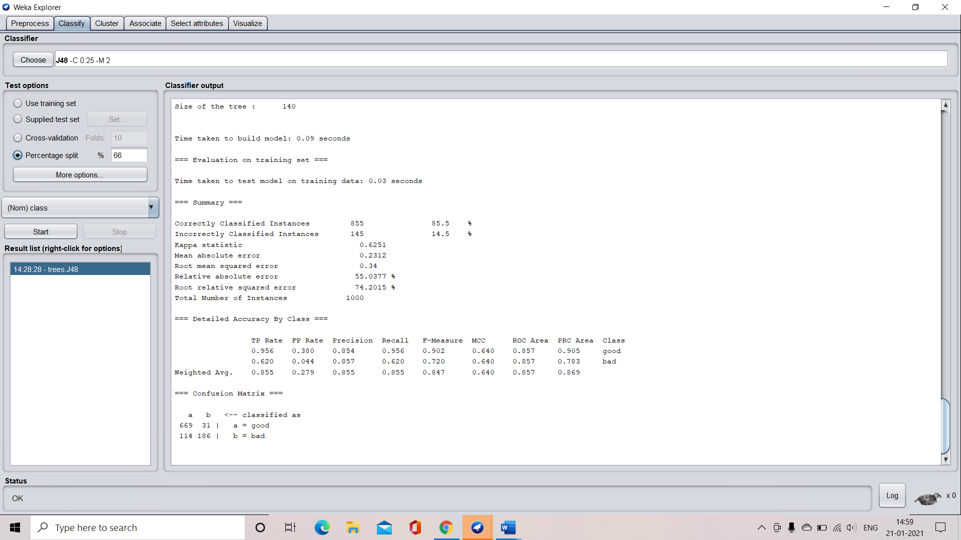

VISUALIZATION OF THE DECISION TREE

Click on the required option present in the result list and select visualize tree option

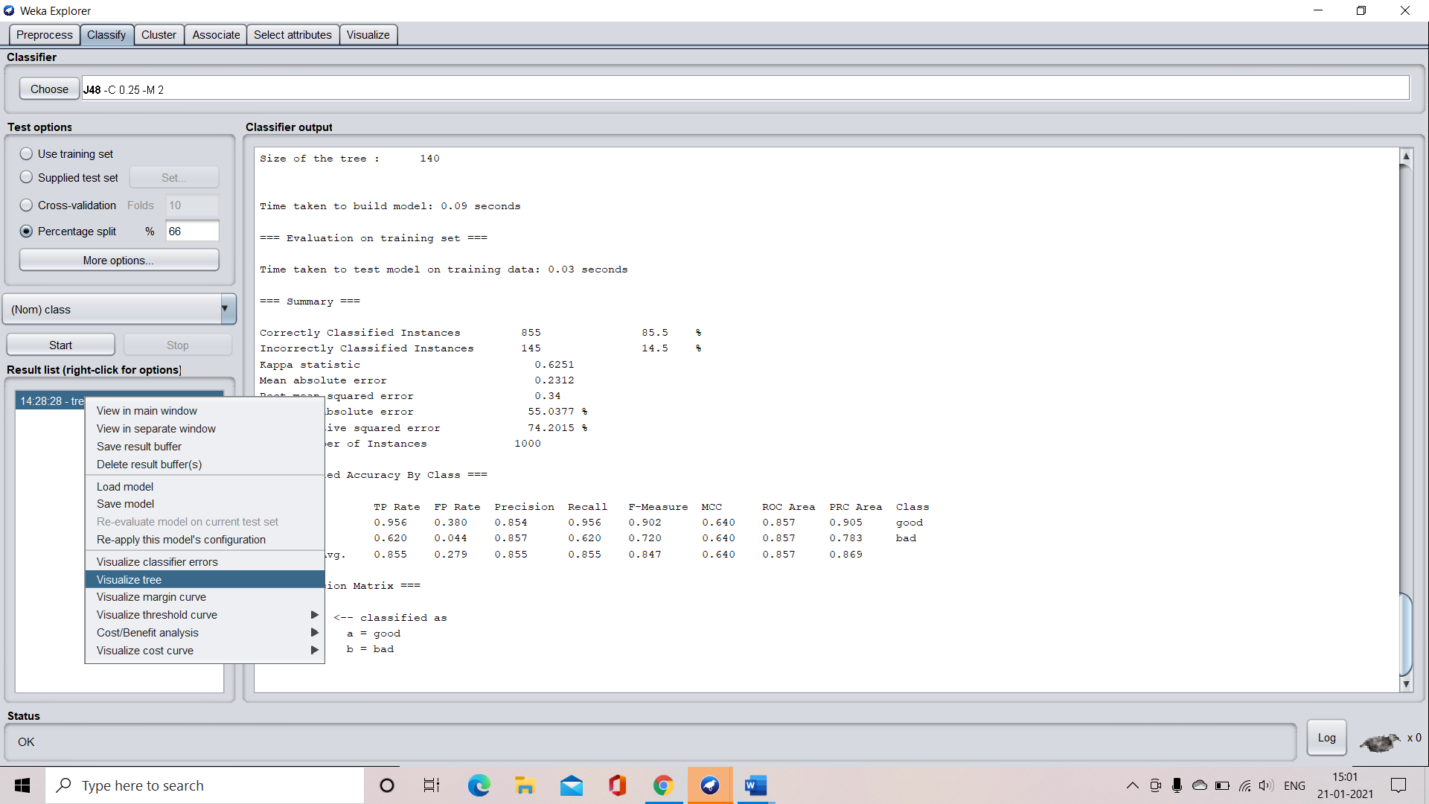

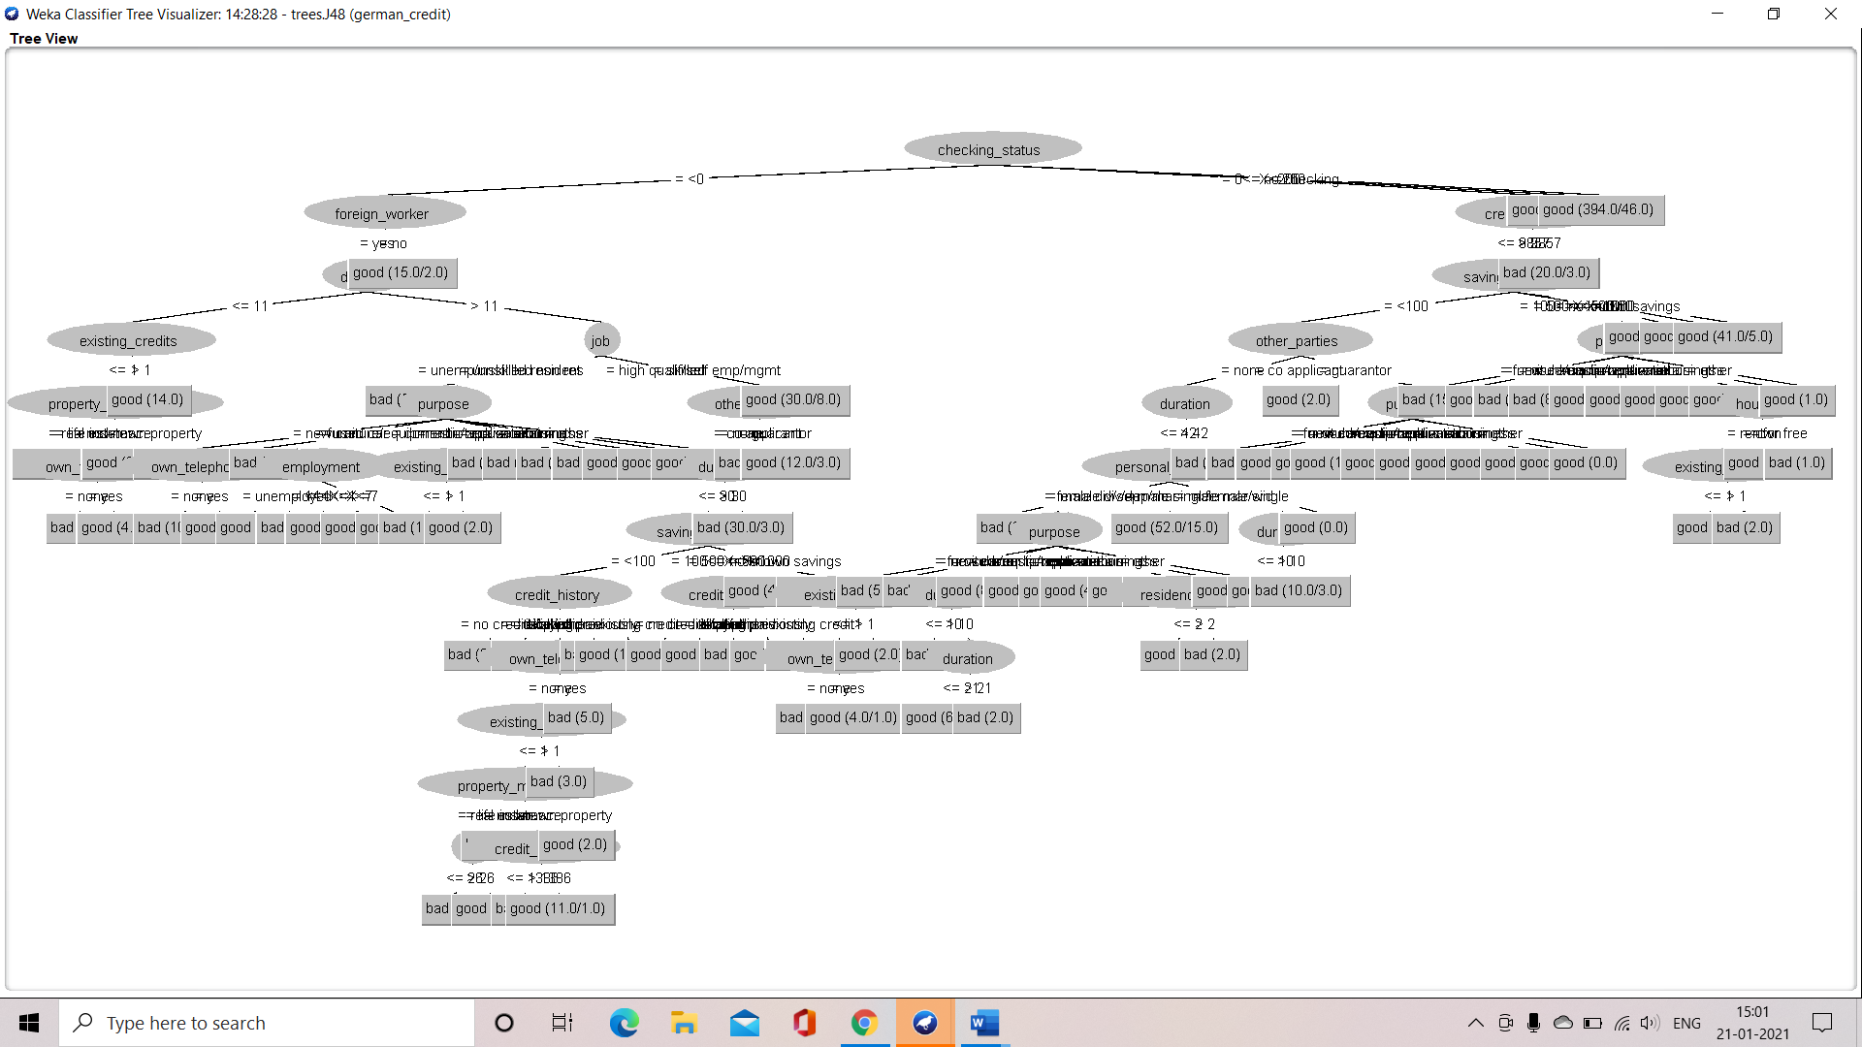

**APPLICATION OF CROSS VALIDATION**

**CASE 1: when the number of folds is 10**

**Step 1:** select the cross validation option

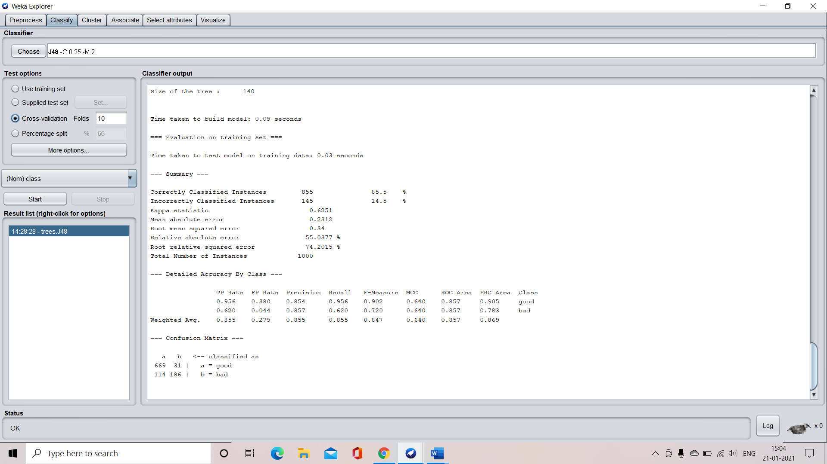

**Step 2:** specify the number of folds that is 10 in our case. And select the start button

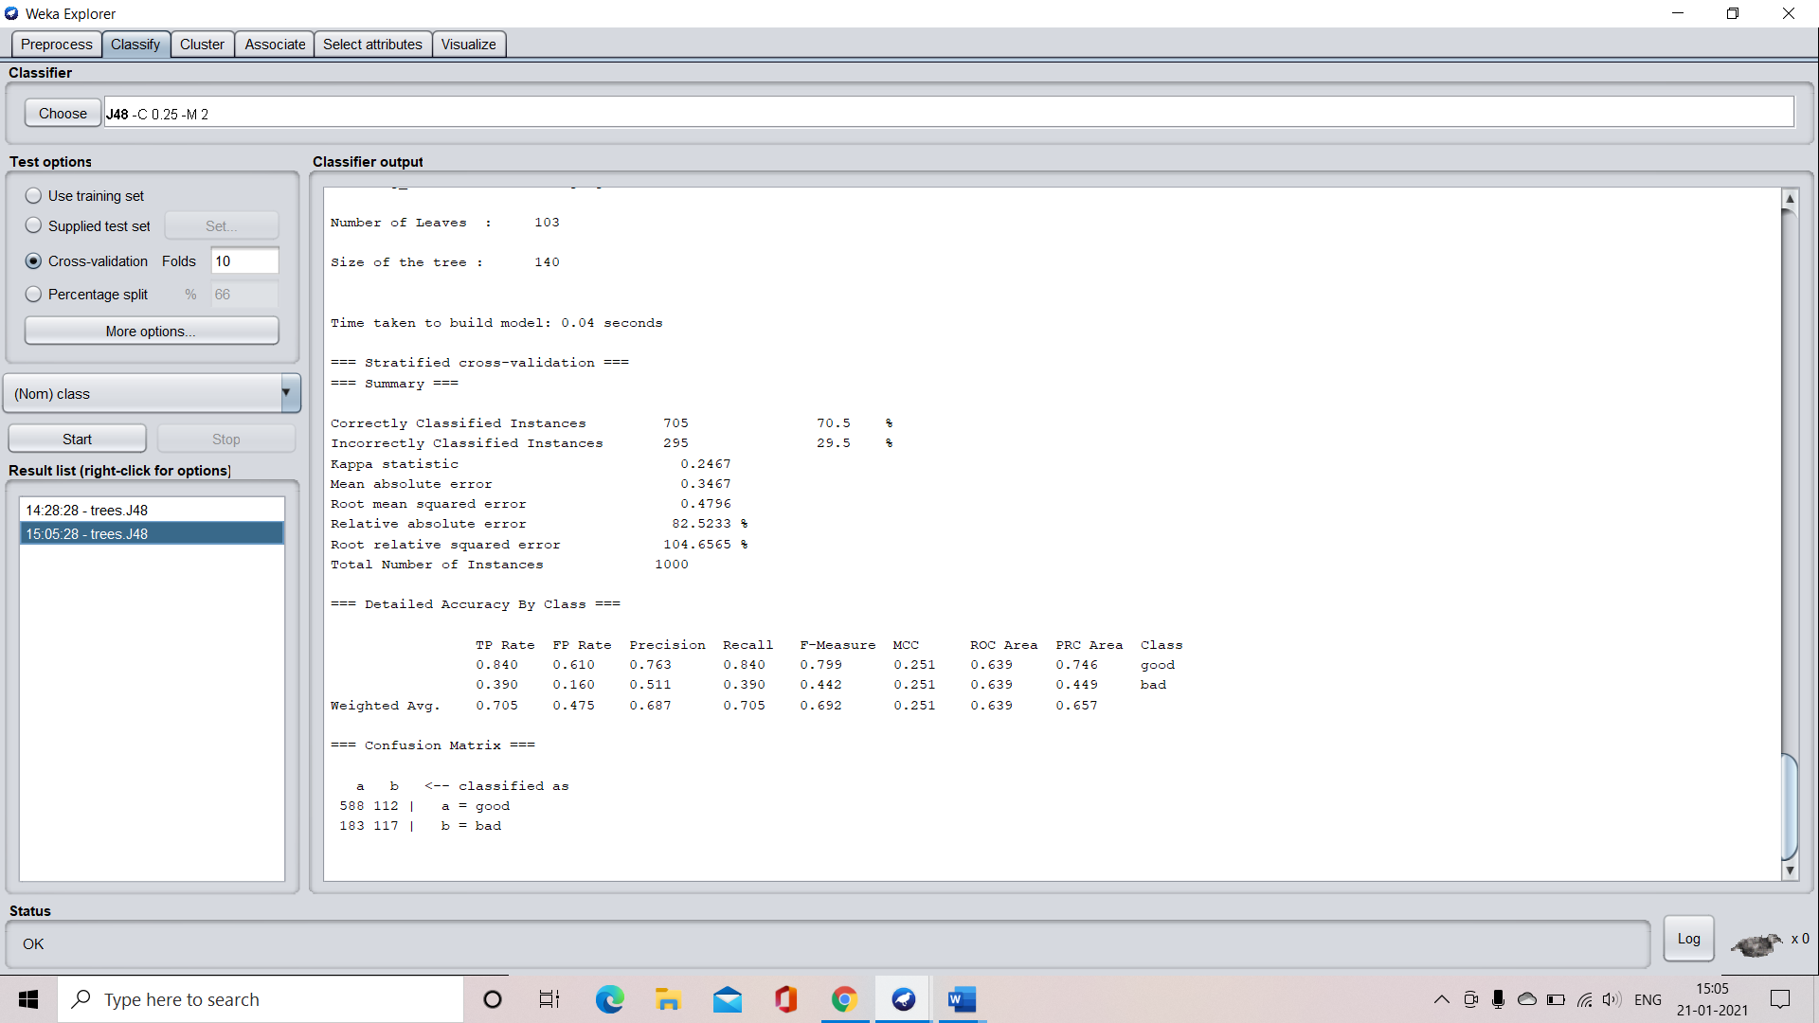

**Step 3:** understand the characteristics of the developed tree

Number of leaves = 103

Size of the tree = 140

Time taken to develop the tree = 0.04 seconds

**Confusion matrix:**



**Accuracy:**



**Step 4:** visualize the decision tree

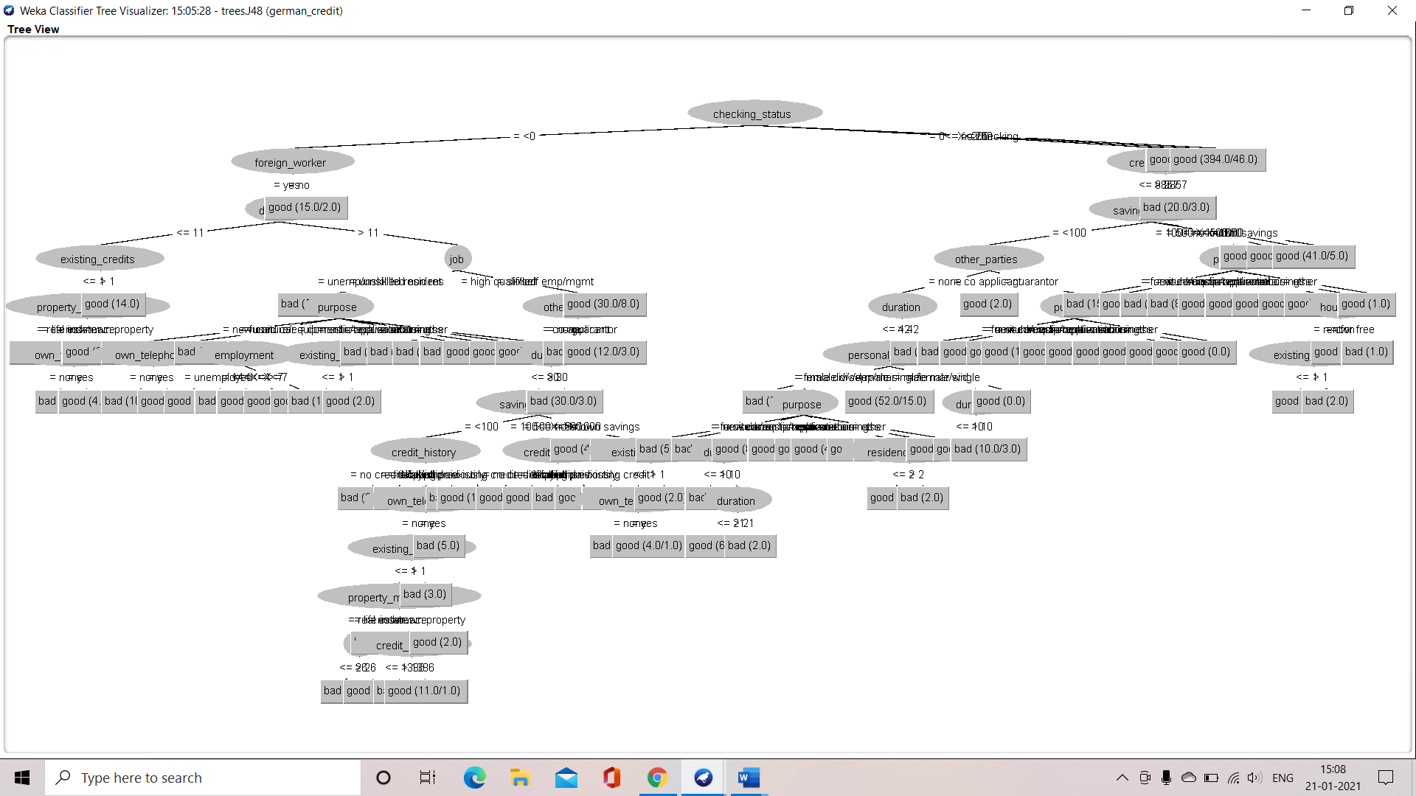

**CASE 2: when the number of folds is 8**

**Step 1:** Select the cross validation option and specify the number of required folds which is 8 in our case. And click the “Start” buttion to train the machine

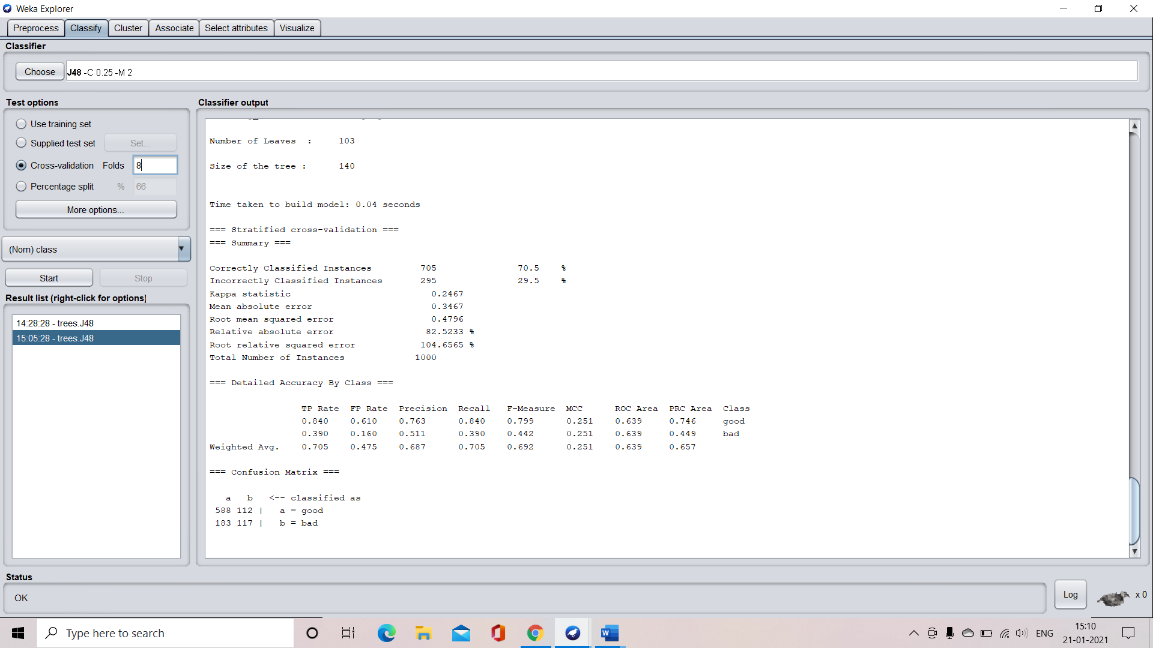

**Step 2:** understand the characteristics if the tree

Number of leaves = 103

Size of the tree = 140

Time taken to develop the tree = 0.02 seconds

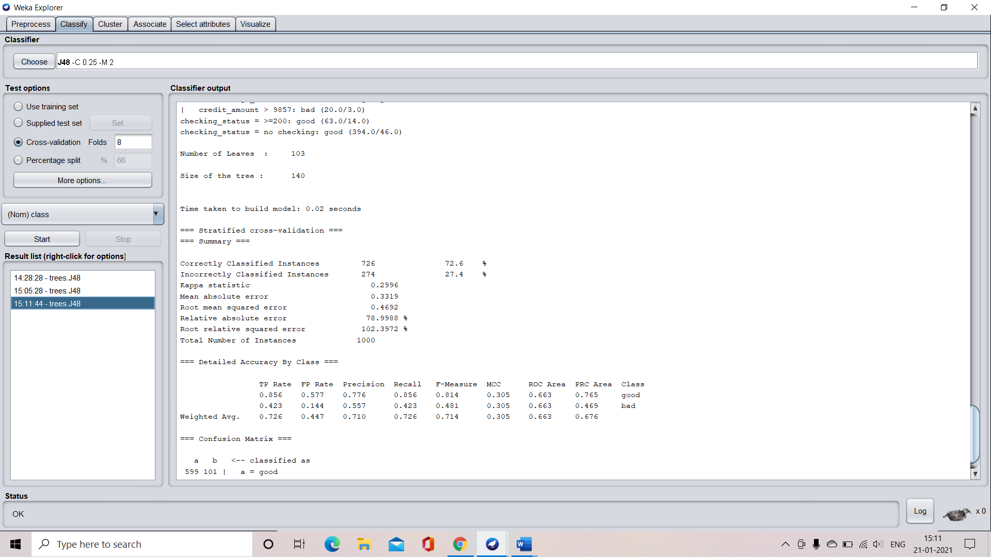

**Confusion matrix:**

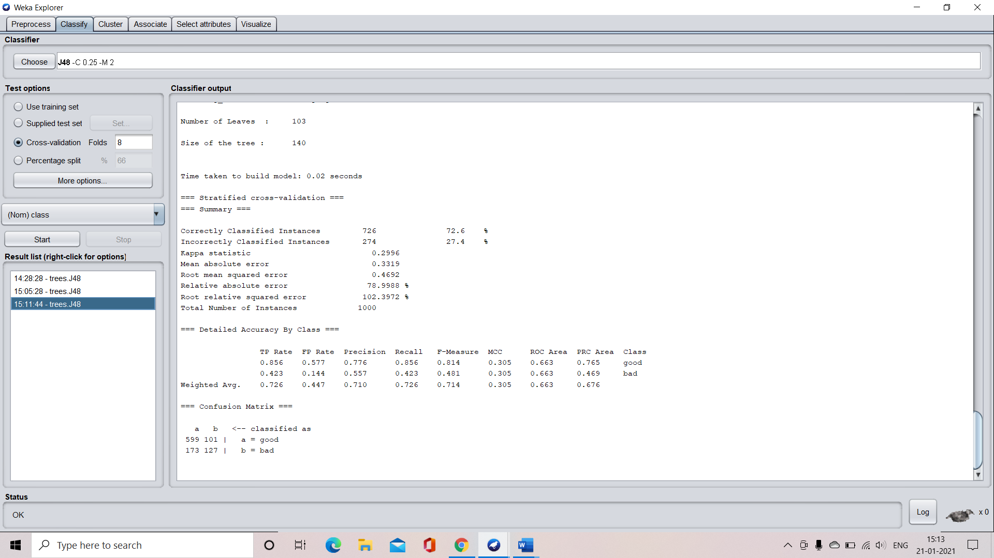

**Accuracy :**



**Step 3:** visualize the decision tree

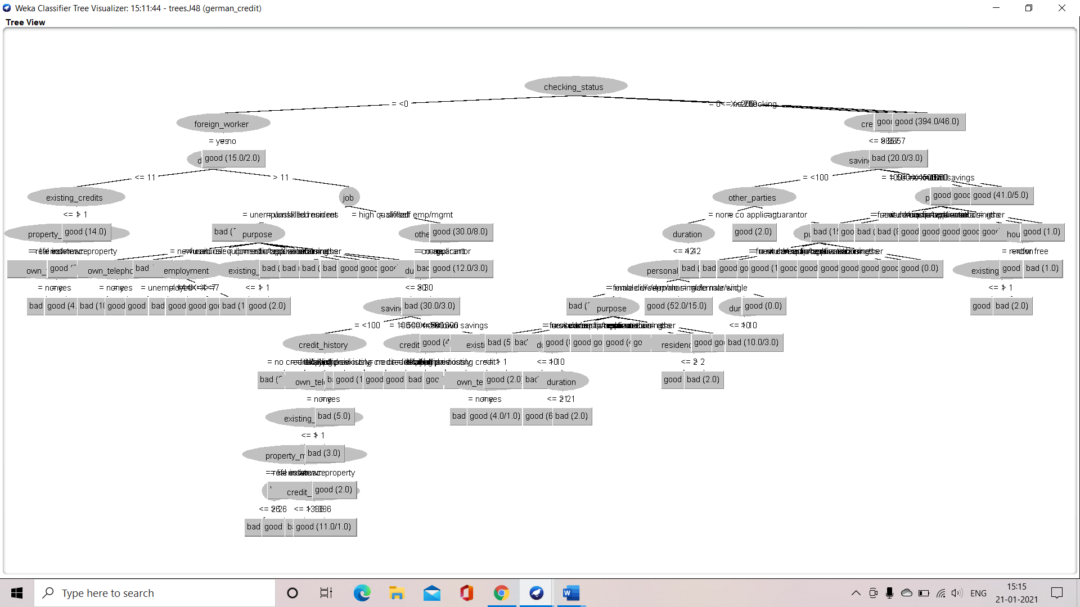

**APPLICATION OF PERCENTAGE SPLIT**

**CASE 1: when the split percentage is 66%**

**Step 1:** select the percentage split option and specify the percentage split which is 66 in our case.

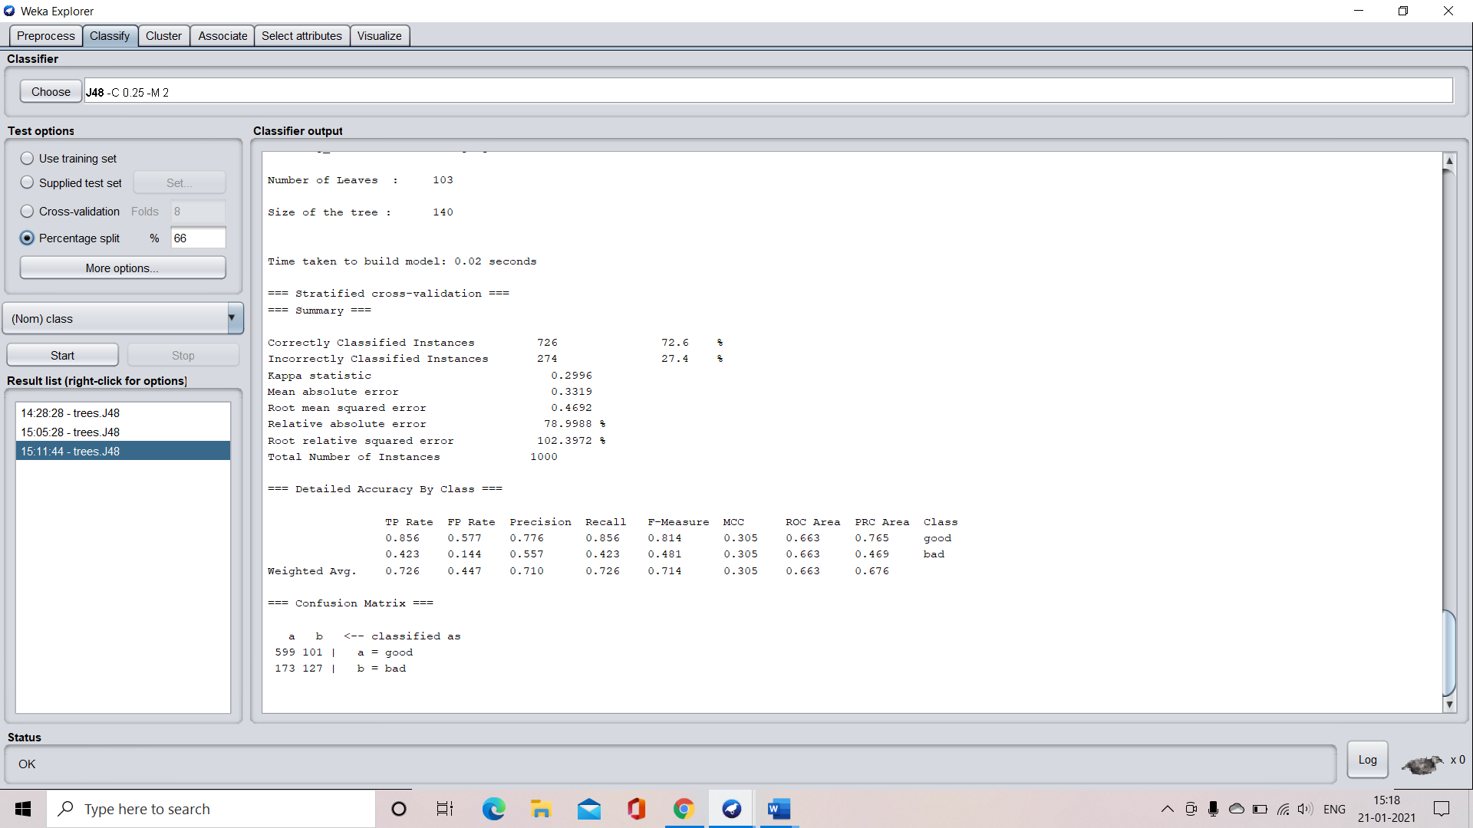

**Step 2:** select the “start” button to train the machine

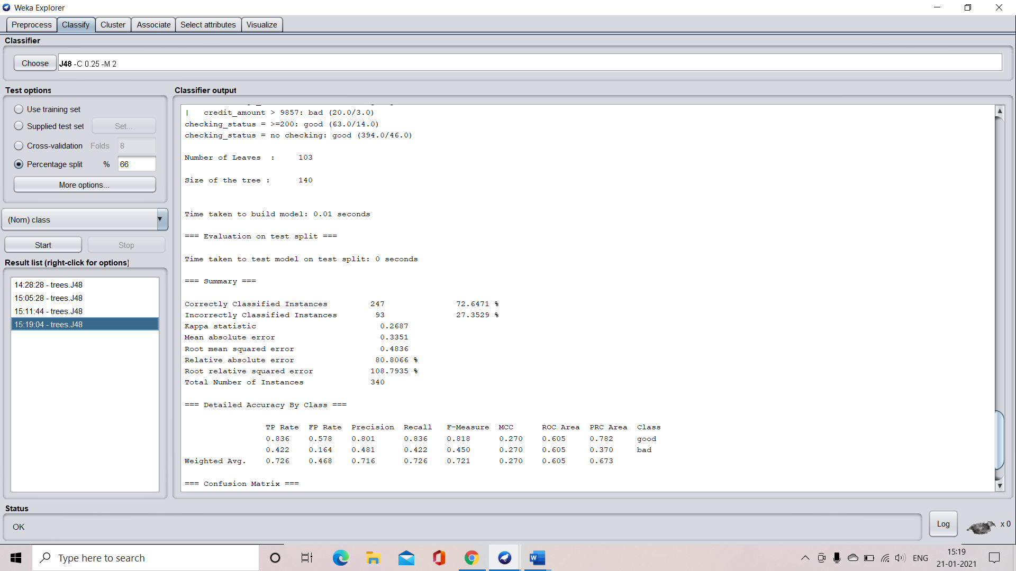

**Step 2:** understand the characteristics of the developed tree

Number of leaves = 103

Size of the tree = 140

Time taken to develop the tree = 0.01 seconds



**Confusion matrix:**

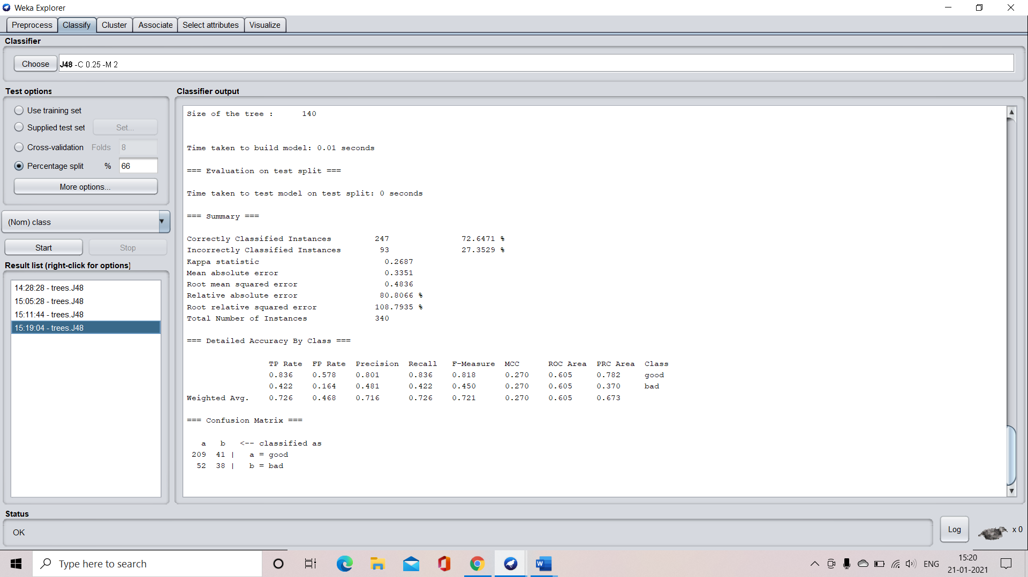

**Accuracy:**



**Step 3:** visualization of the decision tree

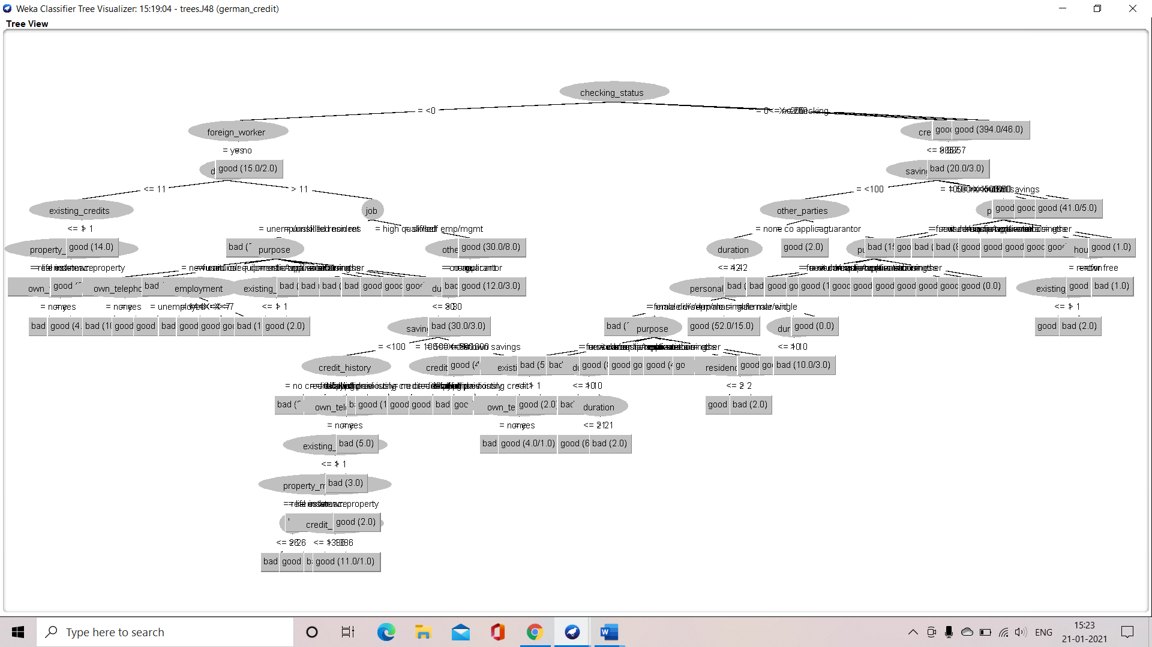

**CASE 2: application when percentage split is 70%**

**Characteristics of the developed decision tree:**

Number of leaves = 103

Size of the tree = 140

Time taken to develop the tree = 0.01 seconds

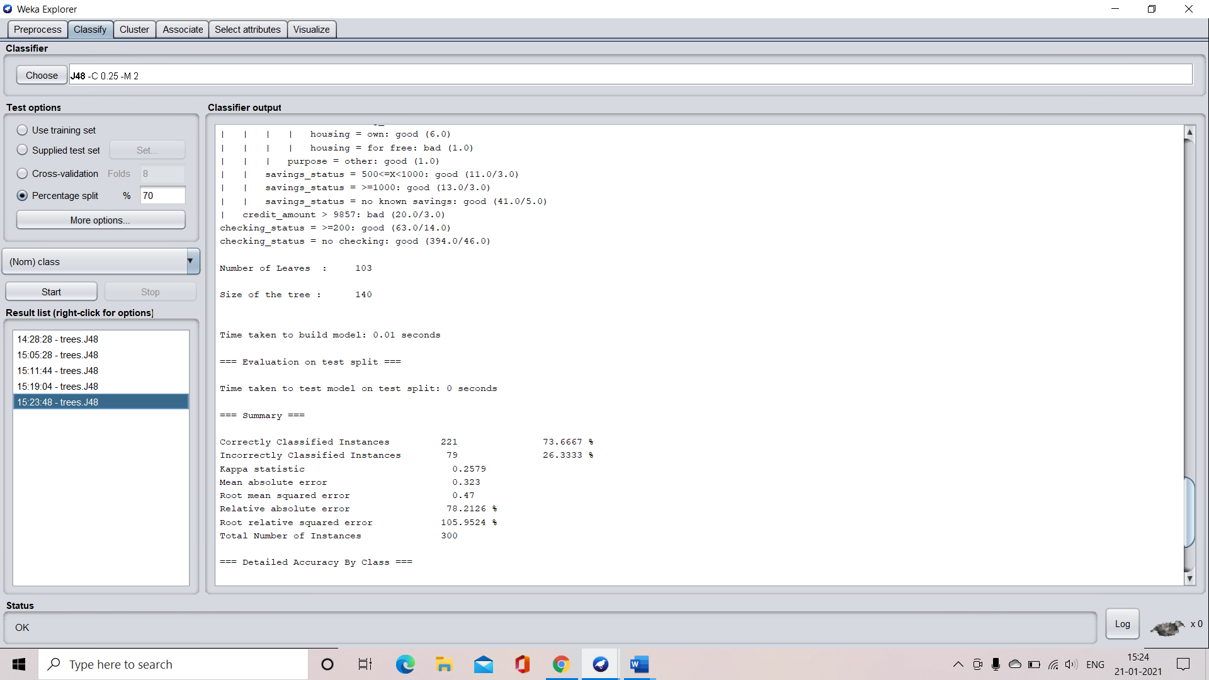

**Confusion matrix:**

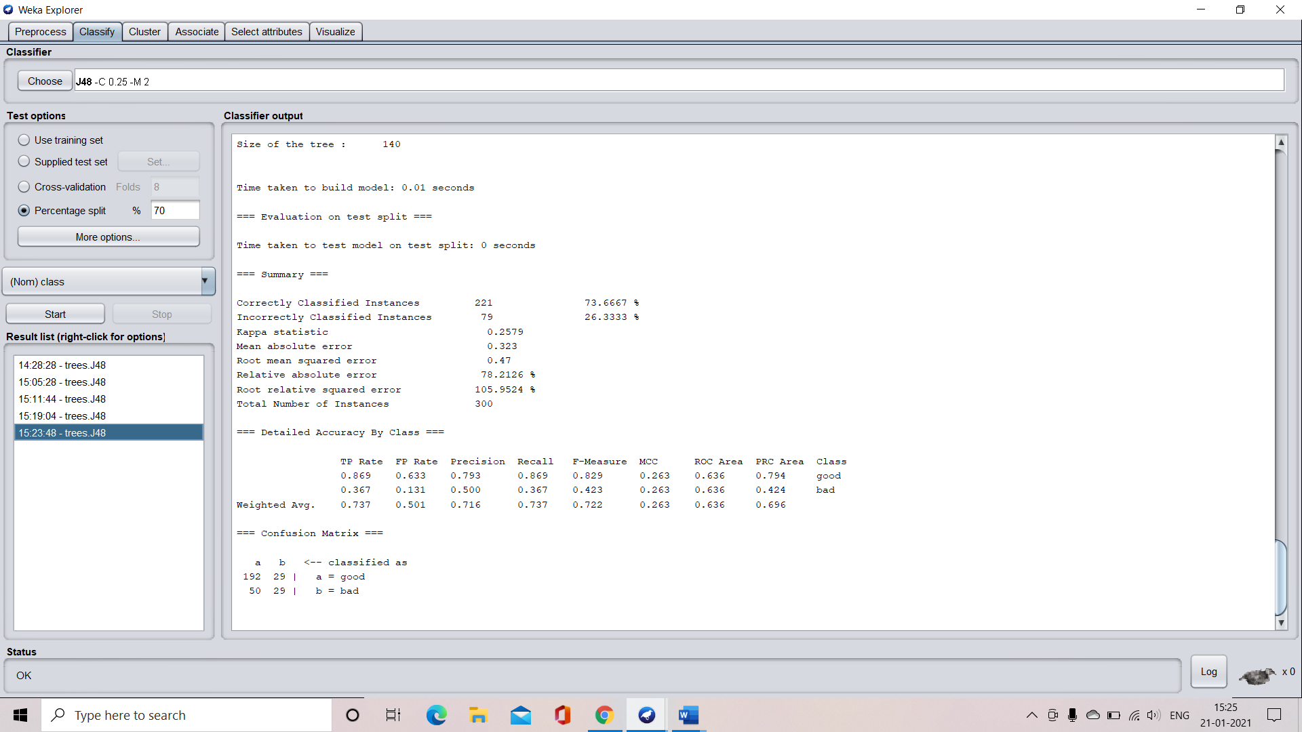

**Accuracy:**



**Decision tree visualization**

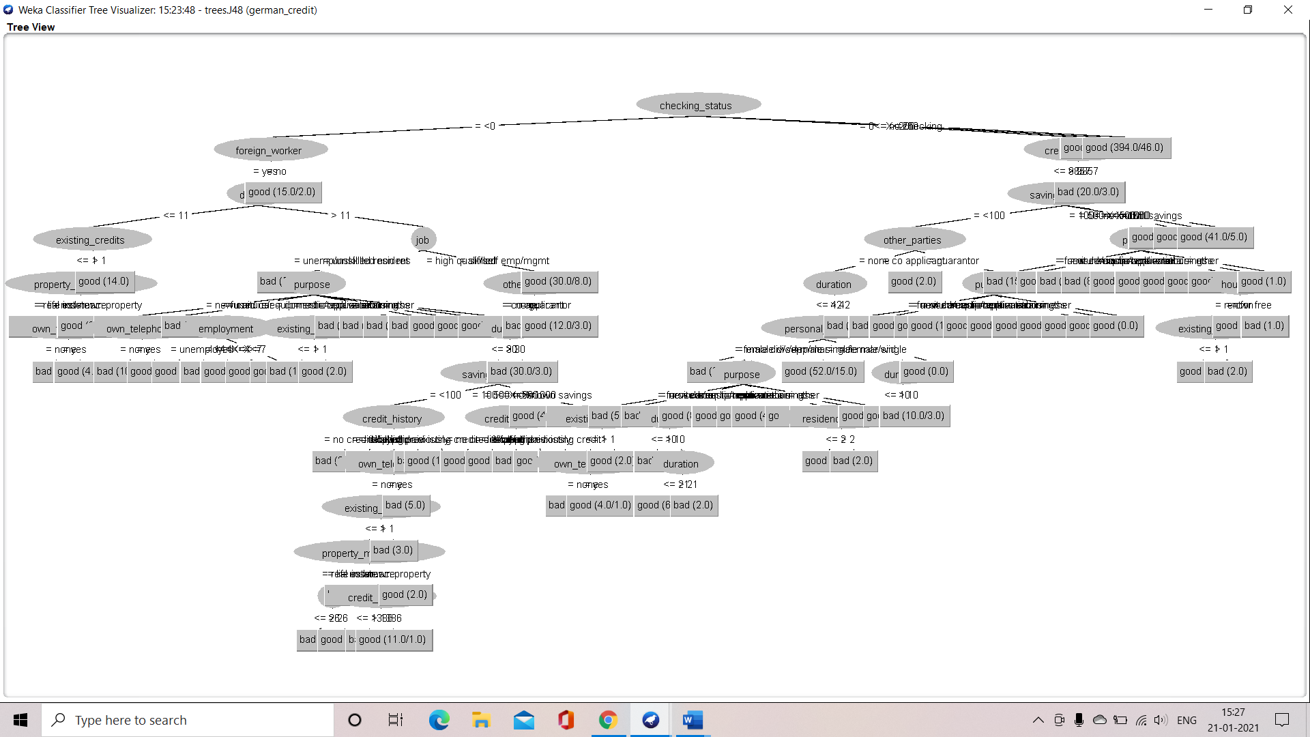

**CASE 3: when the percentage split is 75%**

**Characteristics of the developed decision tree**

Number of leaves = 103

Size of the tree = 140

Time taken to develop the tree = 0.01 seconds

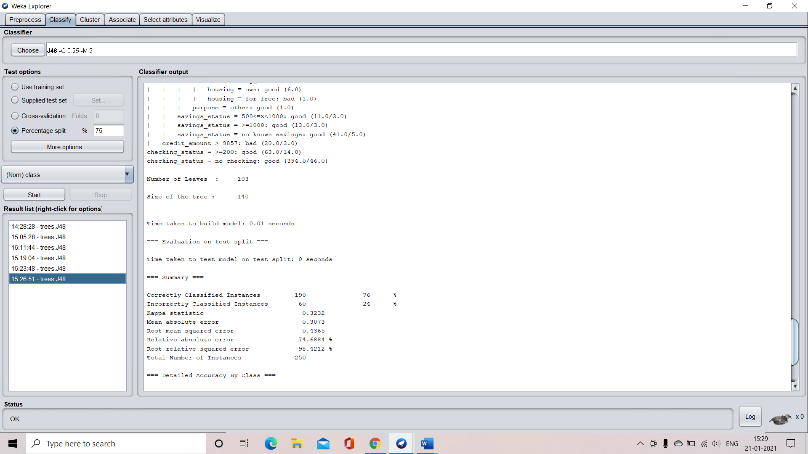

**Confusion matrix:**

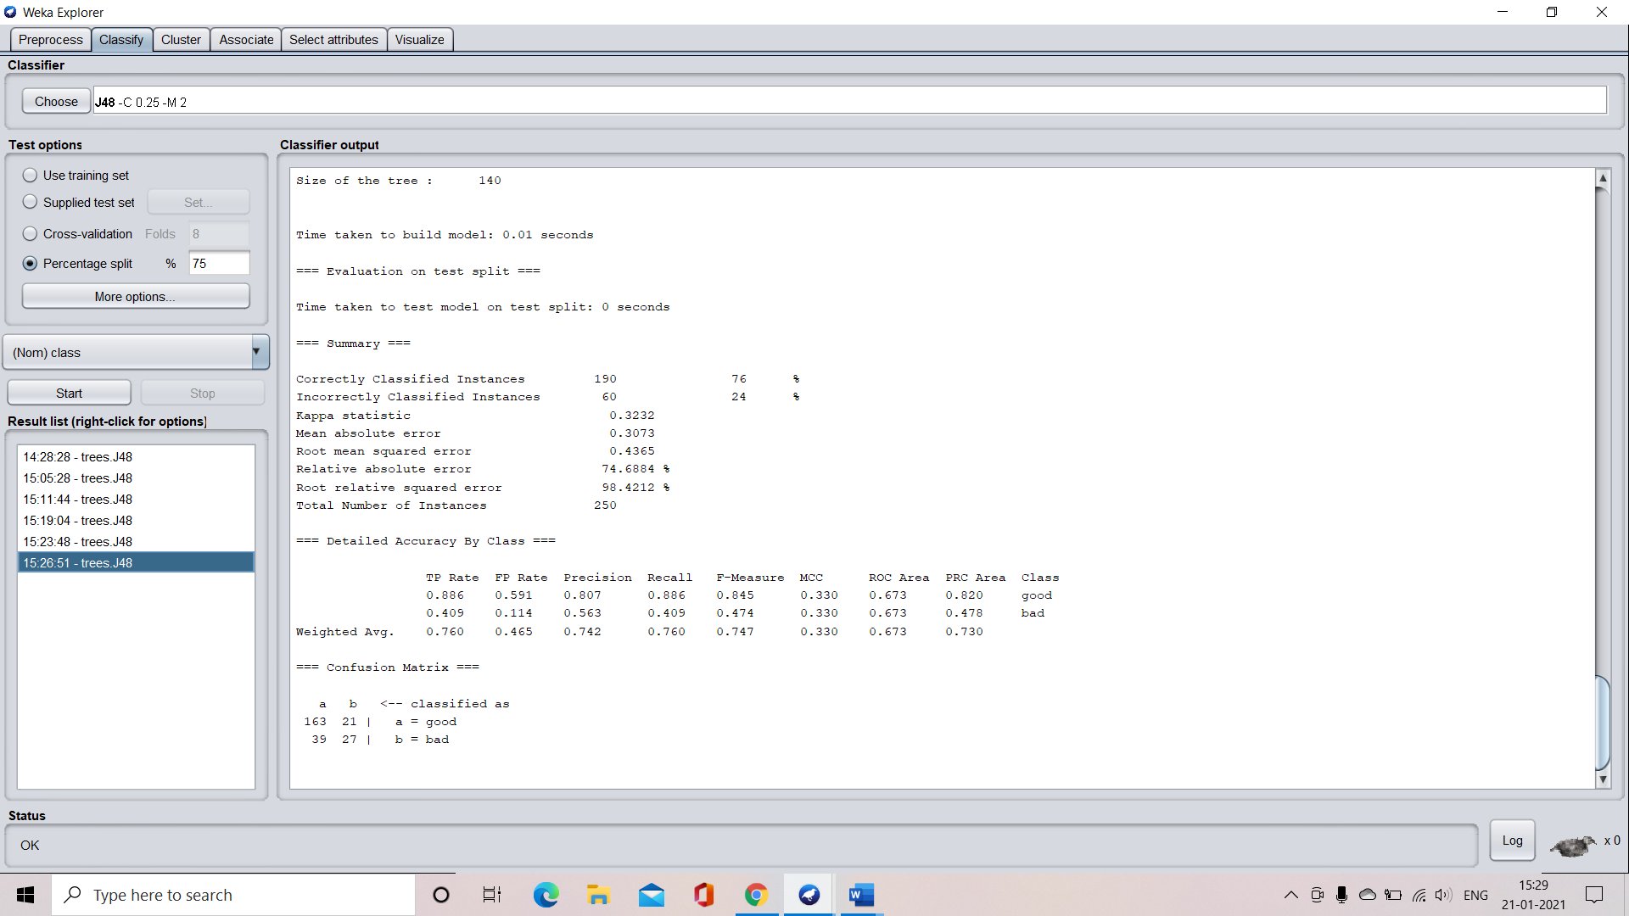

**Accuracy:**



**Visualization of the decision tree**

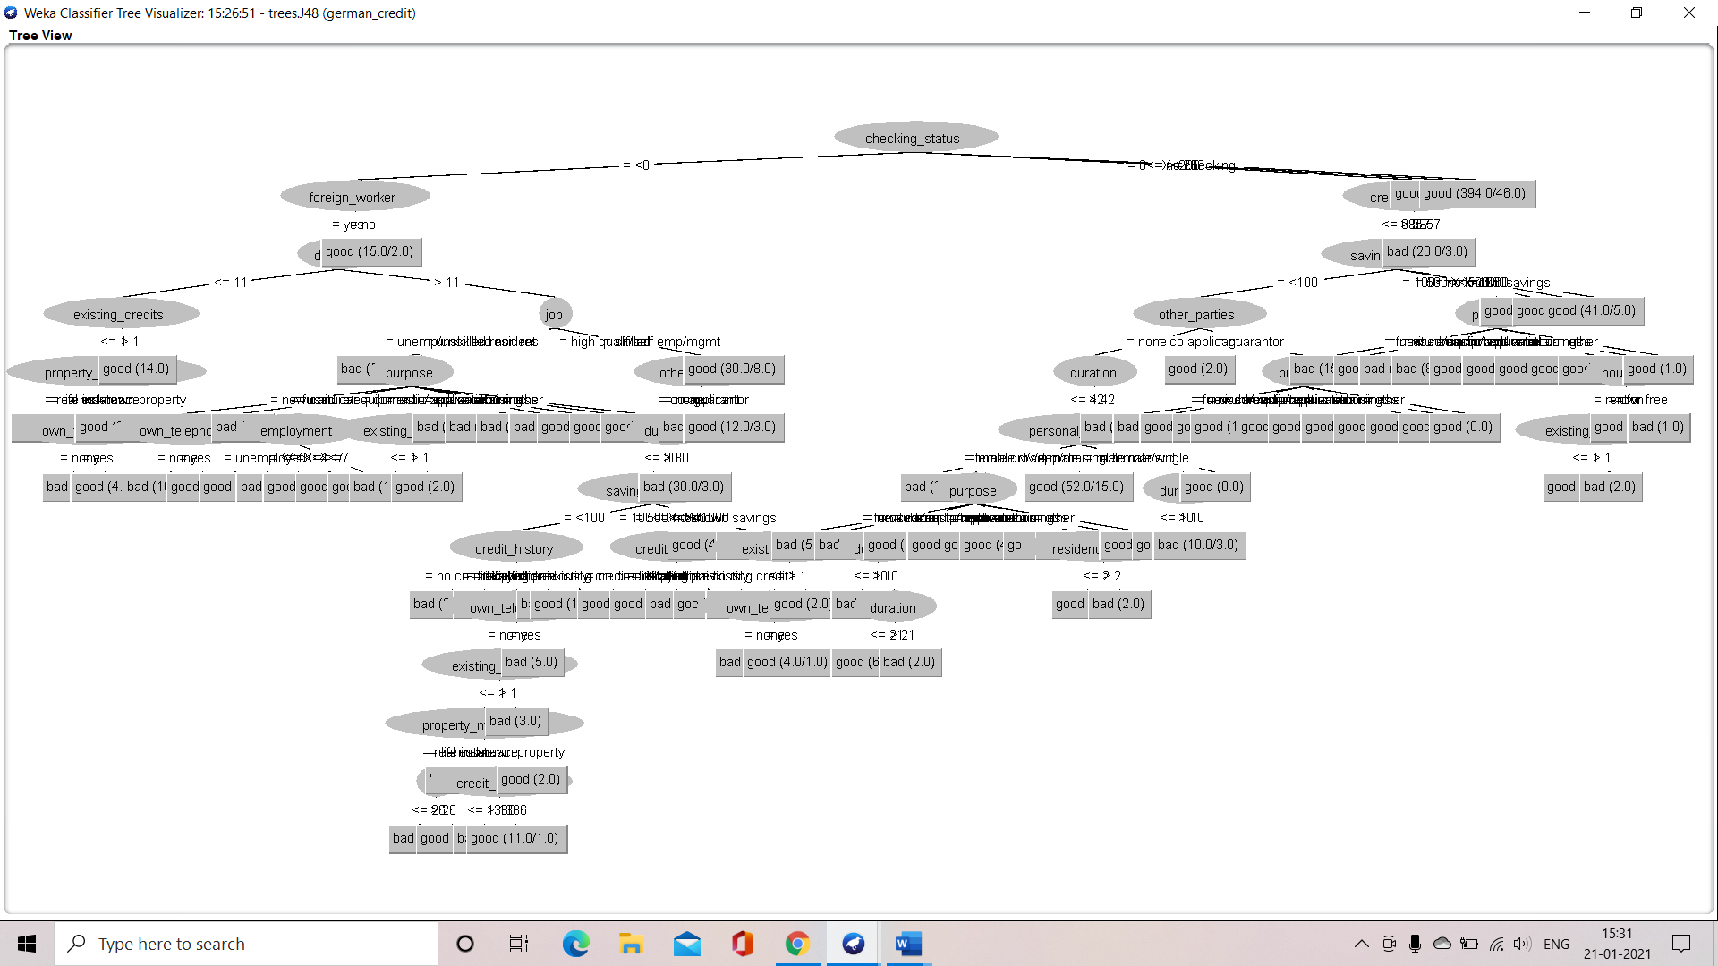

**CASE 4: application when the splitting percentage is 80%**

**Understanding the characteristics of the decision tree**

Number of leaves = 103

Size of the tree = 140

Time taken to build the tree = 0.01 seconds

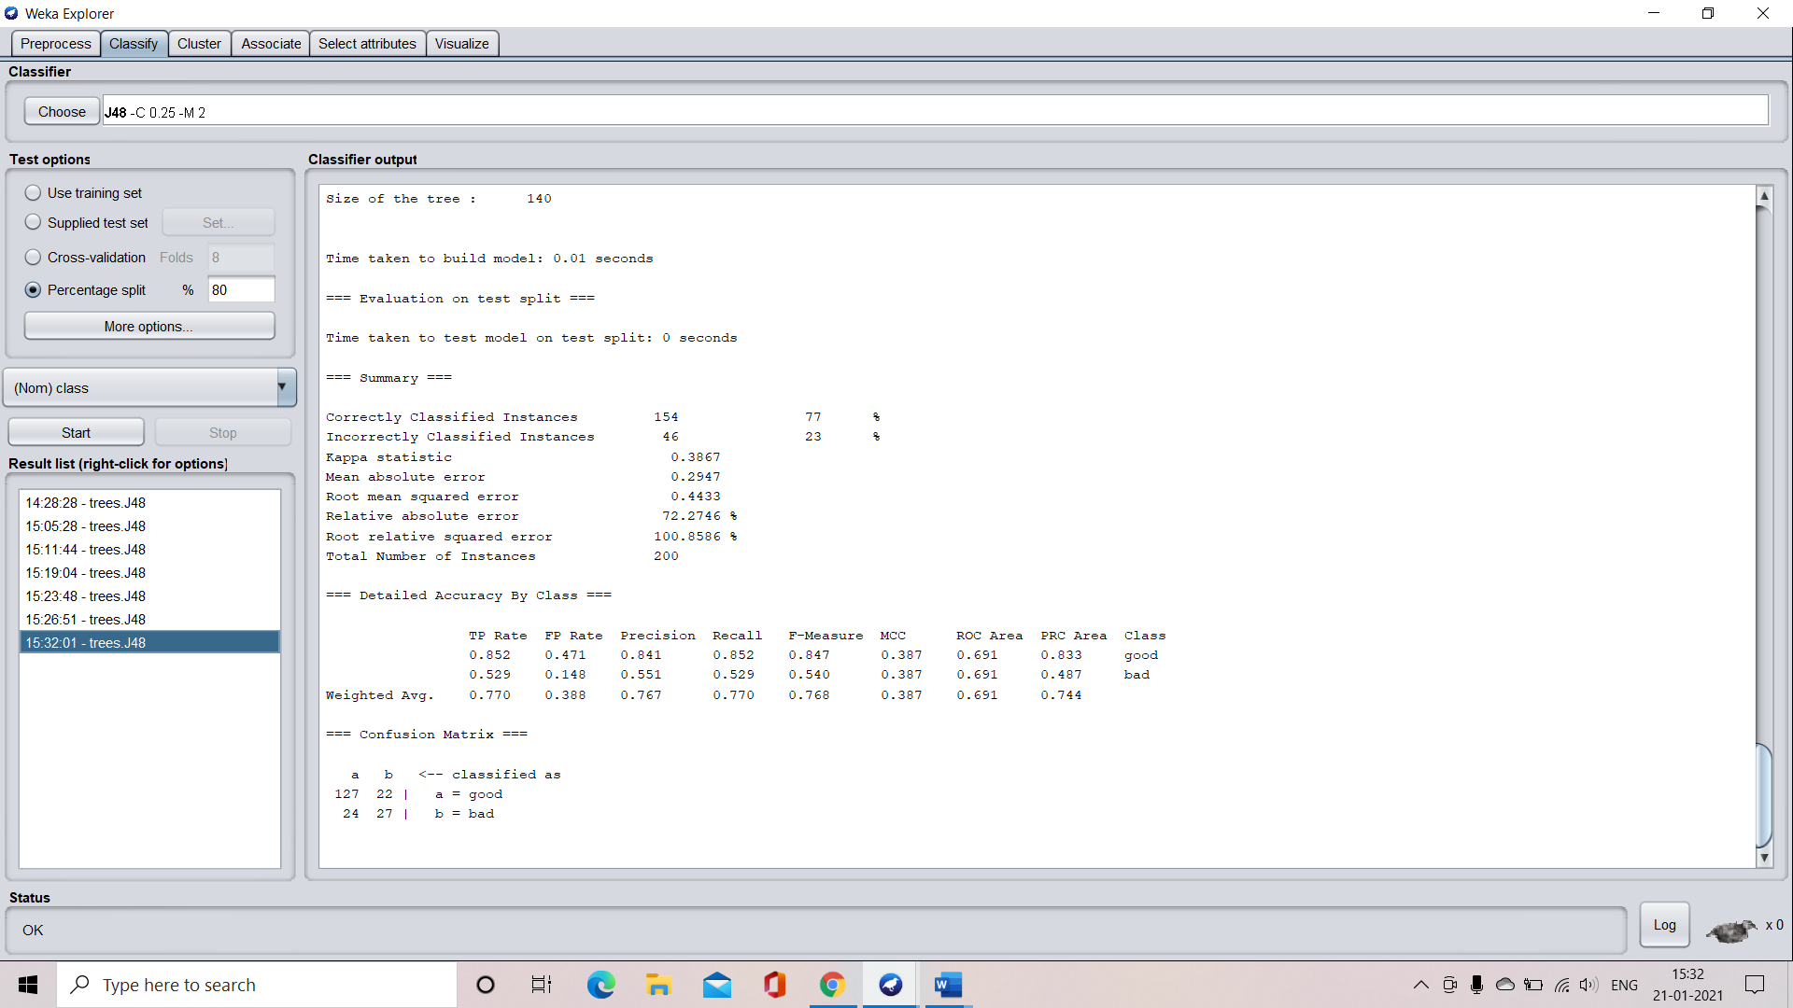

**Confusion matrix:**



**Accuracy:**



**Visualization of the decision tree**

